**Gold Butterfly Wall Mirror**

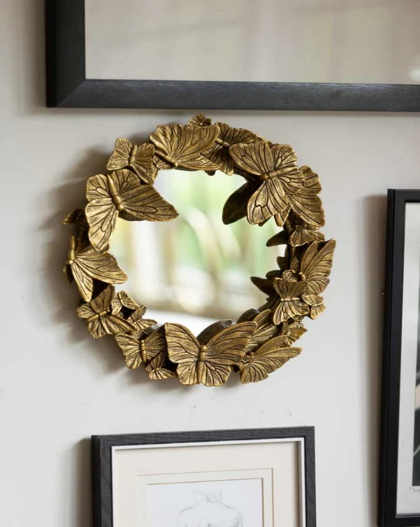The **Gold Butterfly Wall Mirror** is a stunning piece that blends elegance with whimsical charm. Featuring intricate butterfly designs in a rich gold finish, this mirror creates a sense of lightness and beauty in any room. The delicate butterflies, artistically placed around the reflective surface, add a touch of nature-inspired sophistication. Perfect for living rooms, bedrooms, or entryways, this mirror serves as both a functional piece and a work of art. Its radiant gold frame enhances any space, bringing warmth and elegance, while the butterfly motif adds a sense of freedom and grace to your decor.